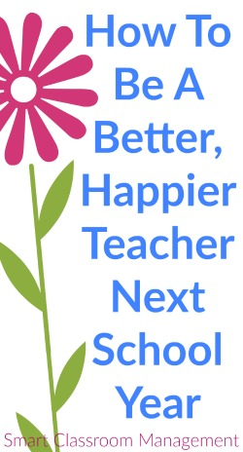
How To Be A Better, Happier Teacher Next School Year
By Michael Linsin on June 18, 2016 24
Before rushing headlong into summer, it’s instructive to take a look back.
To reflect on what went well during the past school year and what didn’t.
Because, unless you know where you need to improve, you’re destined to experience the same frustrations year after year.
So I created a survey based on the core principles and philosophies of SCM.
It will help you pinpoint those areas that stood in your way of truly loving your job.
I recommend giving yourself a score between one and five to represent the degree in which you’re able to answer yes for each item.
Don’t worry, no one is going to see your survey but you.
So be brutally honest.
It’s sure to make you a better, happier teacher next year.
——–
1. I consistently followed my classroom management plan.
2. I held students accountable without becoming angry or taking misbehavior personally.
3. I refrained from lecturing, scolding, yelling, glaring, or using any other form of intimidation.
4. I praised students only for work, effort, or behavior that was truly worthy of it.
5. I built strong leverage, influence, and rapport through my consistently pleasant personality.
6. I avoided external rewards in favor of building intrinsic motivation.
7. I had a good relationship with my most difficult students.
8. I taught routines thoroughly and held my class accountable for performing them with excellence.
9. I taught clear, compelling lessons and then shifted responsibility to my students.
10. I allowed my students to work independently with the least amount of interference from me.
11. I was dependably able to get my students to listen attentively and follow my directions.
12. I prepared efficiently and had ample time to spend with my family and the hobbies I love.
13. I created a peaceful, happy, and orderly room environment that my students loved coming to every day.
14. I experienced a minimal amount of stress throughout the year.
——–
It’s important to point out that the principles listed in the survey are in large part dependent on one another.
They work together synergistically to create a classroom that is best and most enjoyable for you and your students.
This is good news.
It means that even a small change, like becoming more consistent, can improve the other areas as well.
It’s also important to mention that anyone can learn the strategies that will allow you to answer a resounding “yes” to each of the items on the survey.
This is no pie-in-the-sky scenario. Our approach has been proven over and over again with thousands of teachers around the world.
If the survey raised questions about why each item is important, we’ve got you covered.
Plug any of the core terms—like “praise” for example—into the search box (along the menu bar) and you’re sure to get a long list of articles that explain why the strategy is important and how to apply it in your classroom.

